**DayChef Project**

**(INSTRUCTION HOW TO USE )**

* **Instructions:-**

1. **Node.js (Download/install)**

**Step 1-**: Go to the site https://nodejs.org/en/download/ and download the necessary binary files. In our example, we are going to download the 32-bit setup files for Node.js.

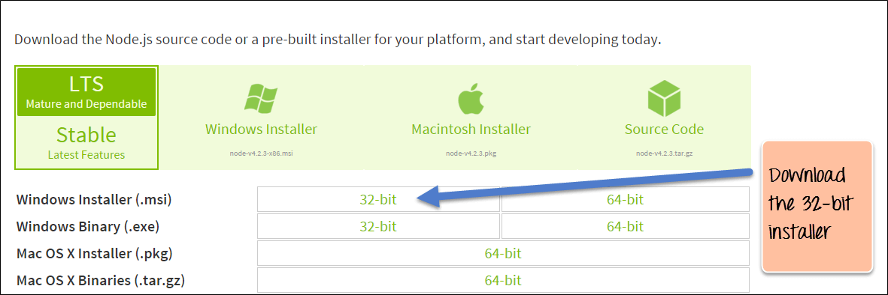

**Step 2-**: Double click on the downloaded .msi file to start the installation. Click the Run button on the first screen to begin the installation.

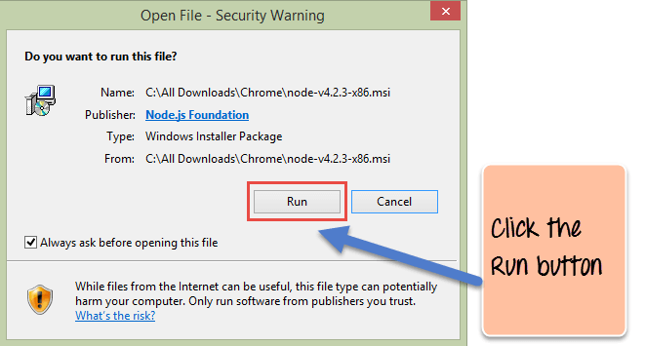

**Step 3-:** In the next screen, click the "Next" button to continue with the installation.

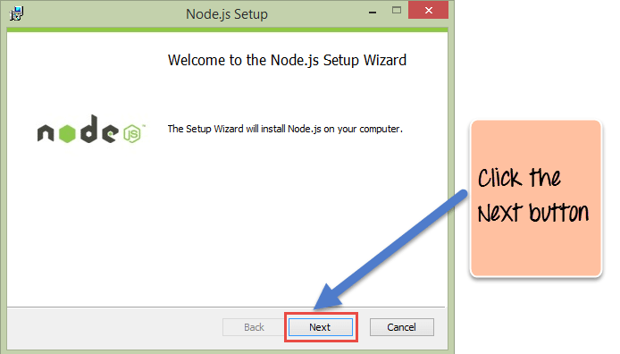

**Step 4-**: In the next screen, Accept the license agreement and click on the Next button.

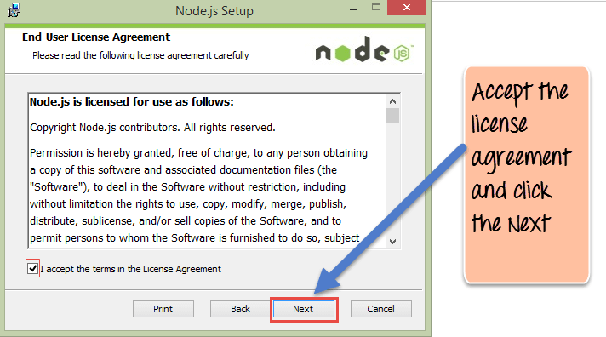

**Step** **5-**: In the next screen, choose the location where Node.js needs to be installed and then click on the Next button.

1. First, enter the file location for the installation of Node.js. This is where the files for Node.js will be stored after the installation.

2. Click on the Next button to proceed ahead with the installation.

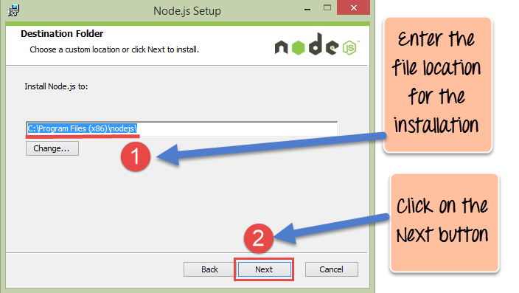

**Step 6-:** Accept the default components and click on the Next button.

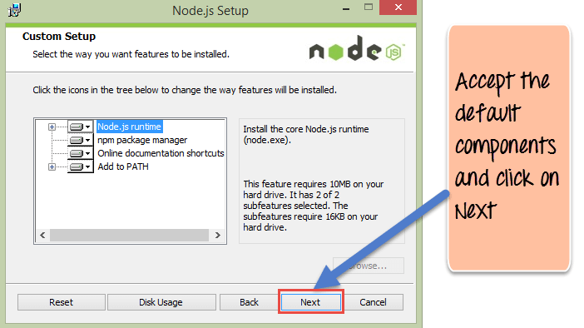

**Step 7-**: In the next screen, click the Install button to start the installation.

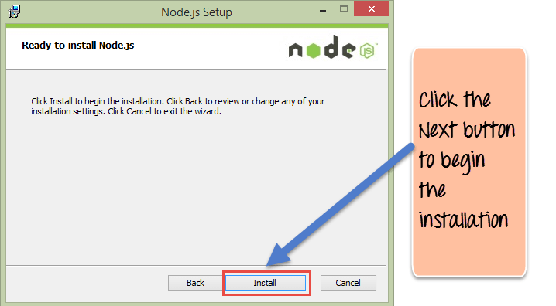

**Step 8-:** Click the Finish button to complete the installation.

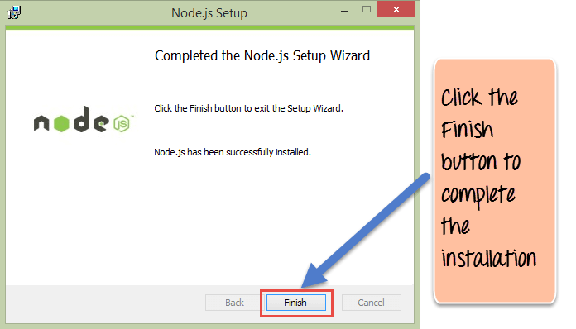

1. **Angular cli configuration**

* npm install -g @angular /cli
* ng new my-dream-app
* Cd my-dream-app
* ng serve

**3. For providing link to backend API and frontend functions**

* Import httpclientmodule in app module
* Make a dataservice ng g s data
* Inject Httpclient in Constructor of data service.

1. **Creating Backened**
2. Create new folder "backend"
3. Navigate into backend and then npm init
4. Create Index.js inside backend.
5. run command

Npm i express body-cors Mongo dB--save

1. Write code in index.js
2. run node index.js

**5. Generate Route Guard**

1. Generating Roud Guard

ng g guard auth

1. Configure Functions.
2. Apply on path.

**6. Mango DB Atlas**

1. Create an Atlas Account.
2. Deploy a Free Tier Cluster.
3. Whitelist Your Connection IP Address.
4. Create a Database User for Your Cluster.
5. Connect to Your Cluster.
6. Insert and View Data in Your Cluster.

